Footprint: Detecting Sybil Attack in Urban Vehicular Network

A PROJECT REPORT

in the partial fulfillment for the award of the degree

of

BACHELOR OF TECHNOLOGY

in

INFORMATION TECHNOLOGY

MAY 2013

BONAFIDE CERTIFICATE

ABSTRACT
In urban vehicular networks, where privacy, especially the location privacy of anonymous vehicles is highly concerned, anonymous verification of vehicles is indispensable. Consequently, an attacker who succeeds in forging multiple hostile identifies can easily launch a Sybil attack, gaining a disproportionately large influence. In this paper, we propose a novel Sybil attack detection mechanism, Footprint, using the trajectories of vehicles for identification while still preserving their location privacy. More specifically, when a vehicle approaches a road-side unit (RSU), it actively demands an authorized message from the RSU as the proof of the appearance time at this RSU. We design a location-hidden authorized message generation scheme for two objectives: first, RSU signatures on messages are signer ambiguous so that the RSU location information is concealed from the resulted authorized message; second, two authorized messages signed by the same RSU within the same given period of time (temporarily linkable) are recognizable so that they can be used for identification.

With the temporal limitation on the linkability of two authorized messages, authorized messages used for long-term identification are prohibited. With this scheme, vehicles can generate a location-hidden trajectory for location-privacy-preserved identification by collecting a consecutive series of authorized messages. Utilizing social relationship among trajectories according to the similarity definition of two trajectories, Footprint can recognize and therefore dismiss “communities” of Sybil trajectories. Rigorous security analysis and extensive trace-driven simulations demonstrate the efficacy of Footprint.

TABLE OF CONTENTS

CHAPTER TITLE PAGE NO.
LIST OF FIGURES ii
LIST OF ABBREVATIONS iii
- INTRODUCTION
  - About the Project 08
- SYSTEM ANALYSIS
  - Existing system 09
  - Proposed system 09
  - System Design 10
3 REQUIREMENTS SPECIFICATION
3.1 Introduction 12
  - Hardware and Software specification 12
  - Technologies Used 13
  - Technologies Used 13 3.4.1 Java 13
3.4.1.1 Introduction to java 13
3.4.1.2 Working of java 15
4 SYSTEM DESIGN
  - Block Diagram

5 SYSTEM DESIGN – DETAILED
5.1 Modules 26
5.2 Module explanation 26
6 CODING AND TESTING
6.1 Coding 31
6.2 Coding standards 31
6.3 Test procedure 34
6.4 Test data and output 35

REFERENCES 78
SNAP SHOTS

LIST OF FIGURES
4 System Design
5.2 Patterns of the peer-peer edges
5.2 Patterns of the service-provider edges
5.2 Discovering missing links in internet

LIST OF ABBREVATIONS

JDK Java Development Toolkit.
JMF Java Media Framework.
TCP Transmission Control Protocol.
IP Internet Protocol.
HTTP Hyper Text Transfer Protocol

CHAPTER 1

INTRODUCTION
Aim:
The main aim of this project is to propose a novel Sybil attack detection Model called Footprint, using the trajectories of vehicles for identification while still preserving their location privacy.

Synopsis:
In vehicular networks, moving vehicles are enabled to communicate with each other via intervehicle communications as well as with road-side units (RSUs) in vicinity via roadside-to-vehicle communications. In urban vehicular Networks where the privacy, especially the location privacy of vehicles should be guaranteed vehicles need to be verified in an anonymous manner.
Without identities of participants, such applications are vulnerable to the Sybil attack where a malicious vehicle masquerades as multiple identities, overwhelmingly influencing the result. Therefore, it is of great importance to detect Sybil attacks from the very beginning of their happening.

CHAPTER 2
SYSTEM ANALYSIS
2.1 EXISTING SYSTEM
Detecting Sybil attacks in urban vehicular networks is a challenging task. First, vehicles are anonymous. There are no chains of trust linking claimed identities to real vehicles. Second, location privacy of vehicles is of great concern. Location information of vehicles can be very confidential.
Third, conversations between vehicles are very short. Due to high mobility of vehicles, a moving vehicle can have only several seconds to communicate with another occasionally encountered vehicle.
In this paper, we propose a novel Sybil attack detection scheme Footprint, using the trajectories of vehicles for identification while still preserving the anonymity and Location privacy of vehicles.

2.2 PROPOSED SYSTEM
First, Footprint does not need the identities of vehicles, which ensures the anonymity of vehicles.
Second, no geographical information is leaked in Footprint, which guarantees the location privacy of vehicles.

CHAPTER 3
REQUIREMENT SPECIFICATIONS
3.1 INTRODUCTION
The requirements specification is a technical specification of requirements for the software products. It is the first step in the requirements analysis process it lists the requirements of a particular software system including functional, performance and security requirements. The requirements also provide usage scenarios from a user, an operational and an administrative perspective. The purpose of software requirements specification is to provide a detailed overview of the software project, its parameters and goals. This describes the project target audience and its user interface, hardware and software requirements. It defines how the client, team and audience see the project and its functionality.

3.2 HARDWARE AND SOFTWARE SPECIFICATION
3.2.1 HARDWARE REQUIREMENTS
- Hard Disk : 80GB and Above
- RAM : 512MB and Above
- Processor : Pentium III and Above

3.2.2 SOFTWARE REQUIREMENTS
- Windows XP
- JDK 1.6
- Netbean IDE 6.9

3.5 TECHNOLOGIES USED
3.5.1 JAVA
It is a Platform Independent. Java is an object-oriented programming language developed initially by James Gosling and colleagues at Sun Microsystems. The language, initially called Oak (named after the oak trees outside Gosling's office), was intended to replace C++, although the feature set better resembles that of Objective C.

3.5.1.1 INTRODUCTION TO JAVA
Java has been around since 1991, developed by a small team of Sun Microsystems developers in a project originally called the Green project. The intent of the project was to develop a platform-independent software technology that would be used in the consumer electronics industry. The language that the team created was originally called Oak.
The first implementation of Oak was in a PDA-type device called Star Seven (*7) that consisted of the Oak language, an operating system called GreenOS, a user interface, and hardware. The name *7 was derived from the telephone sequence that was used in the team's office and that was dialed in order to answer any ringing telephone from any other phone in the office.
Around the time the First Person project was floundering in consumer electronics, a new craze was gaining momentum in America; the craze was called "Web surfing." The World Wide Web, a name applied to the Internet's millions of linked HTML documents was suddenly becoming popular for use by the masses. The reason for this was the introduction of a graphical Web browser called Mosaic, developed by ncSA. The browser simplified Web browsing by combining text and graphics into a single interface to eliminate the need for users to learn many confusing UNIX and DOS commands. Navigating around the Web was much easier using Mosaic.
It has only been since 1994 that Oak technology has been applied to the Web. In 1994, two Sun developers created the first version of Hot Java, and then called Web Runner, which is a graphical browser for the Web that exists today. The browser was coded entirely in the Oak language, by this time called Java. Soon after, the Java compiler was rewritten in the Java language from its original C code, thus proving that Java could be used effectively as an application language. Sun introduced Java in May 1995 at the Sun World 95 convention.
Web surfing has become an enormously popular practice among millions of computer users. Until Java, however, the content of information on the Internet has been a bland series of HTML documents. Web users are hungry for applications that are interactive, that users can execute no matter what hardware or software platform they are using, and that travel across heterogeneous networks and do not spread viruses to their computers. Java can create such applications.

3.3.1.1 WORKING OF JAVA
For those who are new to object-oriented programming, the concept of a class will be new to you. Simplistically, a class is the definition for a segment of code that can contain both data (called attributes) and functions (called methods).
When the interpreter executes a class, it looks for a particular method by the name of main, which will sound familiar to C programmers. The main method is passed as a parameter an array of strings (similar to the argv[] of C), and is declared as a static method.
To output text from the program, we execute the println method of System.out, which is java’s output stream. UNIX users will appreciate the thoery behind such a stream, as it is actually standard output. For those who are instead used to the Wintel platform, it will write the string passed to it to the user’s program.
Java consists of two things :
  - Programming language
  - Platform
3.3.1.2 THE JAVA PROGRAMMING LANGUAGE
Java is a high-level programming language that is all of the following:
  - Simple
  - Object-oriented
  - Distributed
  - Interpreted
  - Robust
  - Secure
  - Architecture-neutral
  - Portable
  - High-performance
  - Multithreaded
  - Dynamic
The code and can bring about changes whenever felt necessary. Some of the standard needed to achieve the above-mentioned objectives are as follows:
Java is unusual in that each Java program is both co implied and interpreted. With a compiler, you translate a Java program into an intermediate language called Java byte codes – the platform independent codes interpreted by the Java interpreter. With an interpreter, each Java byte code instruction is parsed and run on the computer. Compilation happens just once; interpretation occurs each time the program is executed. This figure illustrates how it works :
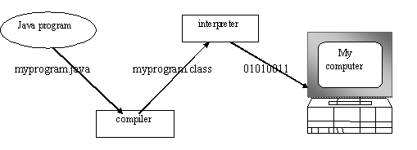
Fig.3.1
You can think of Java byte codes as the machine code instructions for the Java Virtual Machine (JVM). Every Java interpreter, whether it’s a Java development tool or a Web browser that can run Java applets, is an implementation of JVM. That JVM can also be implemented in hardware. Java byte codes help make “write once, run anywhere” possible.
You can compile your Java program into byte codes on any platform that has a Java compiler. The byte codes can then be run on any implementation of the JVm. For example, that same Java program can e run on Windows NT, Solaris and Macintos

Java program
Complier

Interpreter
Interpreter
Interpreter

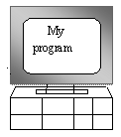
PC-Compatible Sun Ultra Solaris Power macintosh
Windows NT System 8

3.3.1.3 THE JAVA PLATFORM
A platform is the hardware or software environment in which a program runs. The Java platform differs from most other platforms in that it’s a software-only platform that runs on top of other, hardware-based platforms. Most other platforms are described as a combination of hardware and operating system.
The Java platform has two components :
- The Java Virtual Machine (JVM)
- The Java Application Programming Interface (Java API)
You’ve already been introduced to the JVM. It’s the base for the Java platform and is ported onto various hardware-based platforms.
The Java API is a large collection of ready-made software components that provide many useful capabilities, such as graphical user interface (GUI) widgets. The Java API is grouped into libraries (packages) of related components. The following figure depicts a Java program, such as an application or applet, that’s running on the Java platform. As the figure shows, the Java API and Virtual Machine insulates the Java program from hardware dependencies.
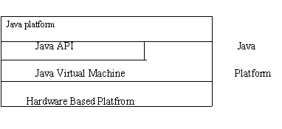
Fig.3.3
As a platform-independent environment, Java can be a bit slower than native code. However, smart compliers, weel-tuned interpreters, and just-in-time byte complilers can bring Java’s performance close to that of native code without threatening protability.

3.5.1.2 WORKING OF JAVA
For those who are new to object-oriented programming, the concept of a class will be new to you. Simplistically, a class is the definition for a segment of code that can contain both data and functions.
When the interpreter executes a class, it looks for a particular method by the name of main, which will sound familiar to C programmers. The main method is passed as a parameter an array of strings (similar to the argv[] of C), and is declared as a static method.
To output text from the program, we execute the println method of System.out, which is java’s output stream. UNIX users will appreciate the theory behind such a stream, as it is actually standard output. For those who are instead used to the Wintel platform, it will write the string passed to it to the user’s program.

Introduction to NetBeans
NetBeans refers to both a platform framework for Java desktop applications, and an integrated development environment (IDE) for developing with Java,JavaScript, PHP, Python, Groovy, C, C++, Scala, Clojure, and others. The NetBeans IDE 7.0 no longer supports Ruby and Ruby on Rails.
The NetBeans IDE is written in Java and can run anywhere a compatible JVM is installed, including Windows, Mac OS, Linux, and Solaris. A JDK is required for Java development functionality, but is not required for development in other programming languages.
The NetBeans platform allows applications to be developed from a set of modular software components called modules. Applications based on the NetBeans platform (including the NetBeans IDE) can be extended by third party developers.

Current versions
NetBeans IDE 6.0 introduced support for developing IDE modules and rich client applications based on the NetBeans platform, a Java Swing GUI builder (formerly known as "Project Matisse"), improved CVS support,WebLogic 9 and JBoss 4 support, and many editor enhancements. NetBeans 6 is available in official repositories of major Linux distributions.
NetBeans IDE 6.5, released in November 2008, extended the existing Java EE features (including Java Persistence support, EJB 3 and JAX-WS). Additionally, the NetBeans Enterprise Pack supports development of Java EE 5 enterprise applications, including SOA visual design tools, XML schema tools, web services orchestration (for BPEL), and UML modeling. The NetBeans IDE Bundle for C/C++ supports C/C++ and FORTRAN development.
NetBeans IDE 6.8 is the first IDE to provide complete support of Java EE 6 and the GlassFish Enterprise Server v3. Developers hosting their open-source projects on kenai.com additionally benefit from instant messaging and issue tracking integration and navigation right in the IDE, support for web application development with PHP 5.3 and the Symfony framework, and improved code completion, layouting, hints and navigation in JavaFX projects.
NetBeans IDE 6.9, released in June 2010, added support for OSGi, Spring Framework 3.0, Java EE dependency injection (JSR-299), Zend Framework for PHP, and easier code navigation (such as "Is Overridden/Implemented" annotations), formatting, hints, and refactoring across several languages.
NetBeans IDE 7.0 was released in April 2011. On August 1, 2011, the NetBeans Team released NetBeans IDE 7.0.1, which has full support for the official release of the Java SE 7 platform

NetBeans Platform
The NetBeans Platform is a reusable framework for simplifying the development of Java Swing desktop applications. The NetBeans IDE bundle for Java SE contains what is needed to start developing NetBeans plugins and NetBeans Platform based applications; no additional SDK is required.
Applications can install modules dynamically. Any application can include the Update Center module to allow users of the application to download digitally-signed upgrades and new features directly into the running application. Reinstalling an upgrade or a new release does not force users to download the entire application again.
The platform offers reusable services common to desktop applications, allowing developers to focus on the logic specific to their application. Among the features of the platform are:
- User interface management (e.g. menus and toolbars)
- User settings management
- Storage management (saving and loading any kind of data)
- Window management
- Wizard framework (supports step-by-step dialogs)
- NetBeans Visual Library
- Integrated Development Tools

NetBeans IDE
NetBeans IDE is an open-source integrated development environment. NetBeans IDE supports development of all Java application types (Java SE including JavaFX, (Java ME, web, EJB and mobile applications) out of the box. Among other features are an Ant-based project system, Maven support, refactorings, version control (supporting CVS, Subversion, Mercurial and Clearcase).
Modularity: All the functions of the IDE are provided by modules. Each module provides a well defined function, such as support for the Java language, editing, or support for the CVS versioning system, and SVN. NetBeans contains all the modules needed for Java development in a single download, allowing the user to start working immediately. Modules also allow NetBeans to be extended. New features, such as support for other programming languages, can be added by installing additional modules. For instance, Sun Studio, Sun Java Studio Enterprise, and Sun Java Studio Creator from Sun Microsystems are all based on the NetBeans IDE.

- Introduction

  - Purpose

The main aim of this project is to propose a novel Sybil attack detection Model called Footprint, using the trajectories of vehicles for identification while still preserving their location privacy.
Project Scope
Footprint does not need the identities of vehicles, which ensures the anonymity of vehicles. Second, no geographical information is leaked in Footprint, which guarantees the location privacy of vehicles. Third, Footprint only needs each vehicle to be equipped with a cheap commercial GPS receiver and DSRC wireless communication module. Last, Sybil attack detection can be online independently conducted by a conversation holder (e.g., an individual vehicle or an RSU) which initializes a conversation among vehicles. Besides the advantages, the main limitation of Footprint is that Footprint requires an infrastructure of RSUs and a trust authority (TA) existing in the system in order to generate trajectories and establish trust among entities, respectively.
The Footprint can achieve all design objectives through security, privacy, and performance analysis and extensive trace-driven simulations which involve 2,100 taxies in Shanghai city. Footprint can largely restrict Sybil attacks and enormously reduces the impact of Sybil attacks in urban settings (above 98 percent detection rate).

- Overall Description

  - Product Perspective

In vehicular networks, moving vehicles are enabled to communicate with each other via intervehicle communications as well as with road-side units (RSUs) in vicinity via roadside-to-vehicle communications. In urban vehicular Networks where the privacy, especially the location privacy of vehicles should be guaranteed vehicles need to be verified in an anonymous manner.

  - Product Features

Design of Infrastructure
We take an incremental deployment strategy in Footprint, considering the tradeoff between minimizing the number of RSUs and maximizing the coverage of traffic. As more RSUs are available to install, a smaller distance can be used to deploy
RSUs .It consist of three initialization process namely 1.Setting up TA ,2. Setting up RSUs.,3. Setting up vehicles:

Location-Hidden Authorization generation
In order to be location hidden, authorized messages issued for vehicles from an RSU should possess two properties, i.e., signer ambiguous and temporarily linkable.

The signer ambiguous property means the RSU should not use a
dedicated identity to sign messages. The temporarily linkable property requires two authorized messages are recognizable if and only if they are generated by the same RSU within the same given period of time.

Detecting Sybil Attack

At the conversation, upon request from the conversation holder, all participating vehicles provide their trajectory embedded authorized messages issued within specified event for identification. With submitted messages, the conversation holder verifies each trajectory and refuses those vehicles that fail the message verification. After that,
the conversation holder conducts online Sybil attack detection before further proceeding with the conversation.

  - User Classes and Characteristics
OBU send – Sends the name and availability to the RSU.
RSU-Updates the information about the backbone network connectivity with all OBU’s to the Trust Authority.
2.4 Design and Implementation Constraints

2.5.1 Constraints in Analysis
- Constraints as Informal Text
- Constraints as Operational Restrictions
- Constraints Integrated in Existing Model Concepts
- Constraints as a Separate Concept
- Constraints Implied by the Model Structure

2.5.2 Constraints in Design
- Determination of the Involved Classes
- Determination of the Involved Objects
- Determination of the Involved Actions
- Determination of the Require Clauses
- Global actions and Constraint Realization

2.5.3 Constraints in Implementation
Detecting Sybil attacks in urban vehicular networks, however, is very challenging. First, vehicles are anonymous. There are no chains of trust linking claimed identities to real vehicles.
Second, location privacy of vehicles is of great
Concern. Location information of vehicles can be very confidential. For example, it can be inferred that the driver of a vehicle may be sick from knowing the vehicle is
Parking at a hospital. It is inhibitive to enforce a one-to-one correspondence between claimed identities to real vehicles by verifying the physical presence of a vehicle at a
Particular place and time.
Third, conversations between vehicles are very short. Due to high mobility of vehicles, a moving vehicle can have only several seconds to
Communicate with another occasionally encountered vehicle. It is difficult to establish certain trustworthiness among communicating vehicles in such a short time. This makes it easy for a malicious vehicle to generate a hostile identity but very hard for others to validate. Furthermore, short conversations among vehicles call for online Sybil attack
detection. The detection scheme fails if a Sybil attack is detected after the attack has terminated.
- System Features

We propose a novel Sybil attack detection scheme Footprint, using the trajectories of vehicles for identification while still preserving the anonymity and
Location privacy of vehicles.

- External Interface Requirements

  - User Interfaces
1. All the contents in the project are implemented using Graphical User Interface (GUI) in Java through JavaFX concepts.
2. Every conceptual part of the projects is reflected using the JavaFX.
3. System gets the input and delivers through the GUI based.

  - Hardware Interfaces
Ethernet
Ethernet on the AS/400 supports TCP/IP, Advanced Peer-to-Peer Networking (APPN) and advanced program-to-program communications (APPC).
ISDN
You can connect your AS/400 to an Integrated Services Digital Network (ISDN) for faster, more accurate data transmission. An ISDN is a public or private digital communications network that can support data, fax, image, and other services over the same physical interface. Also, you can use other protocols on ISDN, such as IDLC and X.25.
  - Software Interfaces
This software is interacted with the TCP/IP protocol, Socket and listening on unused ports. Server Socket and listening on unused ports and JDK 1.6
Communication Interfaces
1. TCP/IP protocol.
2. LAN settings.
- Other Nonfunctional Requirements

  - Performance Requirements

The performance of the wireless mesh network, to execute this project on LAN or wifi or Bluetooth communication channel. So we need to one or more than machine to execute the demo. Machine needs the enough hard disk space to install the software and run our project.

  - Safety Requirements

1. The software may be safety-critical. If so, there are issues associated with its integrity level
2. The software may not be safety-critical although it forms part of a safety-critical system. For example, software may simply log transactions.
3. If a system must be of a high integrity level and if the software is shown to be of that integrity level, then the hardware must be at least of the same integrity level.
4. There is little point in producing 'perfect' code in some language if hardware and system software (in widest sense) are not reliable.
5. If a computer system is to run software of a high integrity level then that system should not at the same time accommodate software of a lower integrity level.
6. Systems with different requirements for safety levels must be separated.
7. Otherwise, the highest level of integrity required must be applied to all systems in the same environment.

  - Security Requirements
Do not block the some available ports through the windows firewall
5.4 Software Quality Attributes
Functionality: are the required functions available, including Interoperability and security
Reliability: maturity, fault tolerance and recoverability
Usability: how easy it is to understand, learn, and operate the software System
Efficiency: performance and resource behavior.
Maintainability: Maintaining the software.
Portability: can the software easily be transferred to another environment,
Including install ability

CHAPTER 4
Architecture:

TA

RSU

RSU

RSU

RSU

OBU

OBU

OBU

OBU

OBU

TA – Trusting Authority
RSU – Road Side Unit
OBU – On Board Unit

Fig: 4.1

4.1 Sequence Diagram:
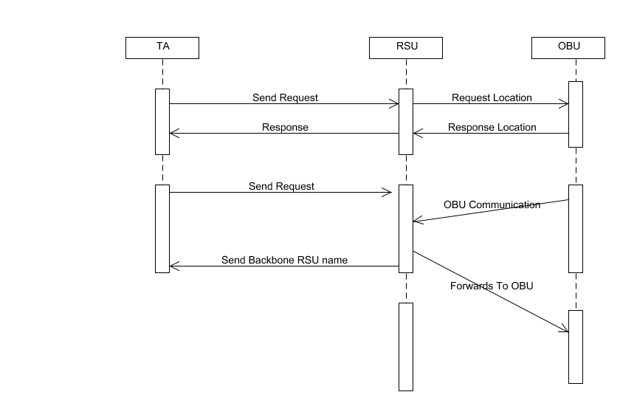

4.2 Use Case Diagram:
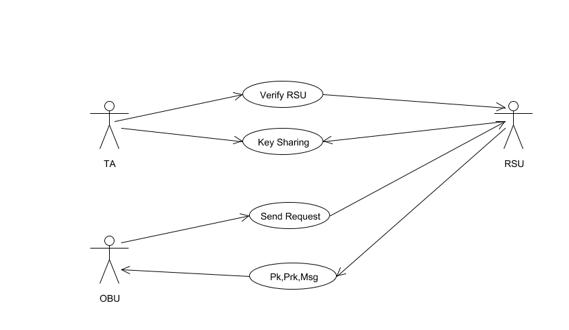

4.3 Activity Diagram:
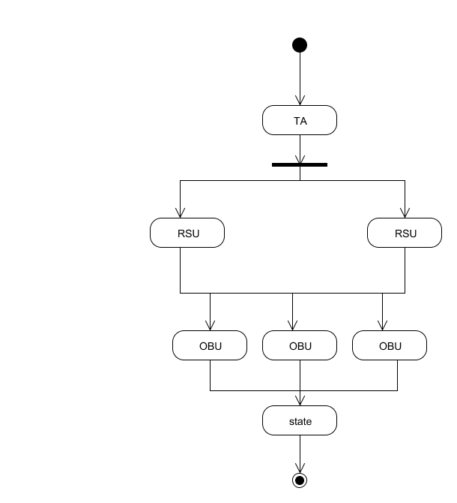

Collaboration Diagram:

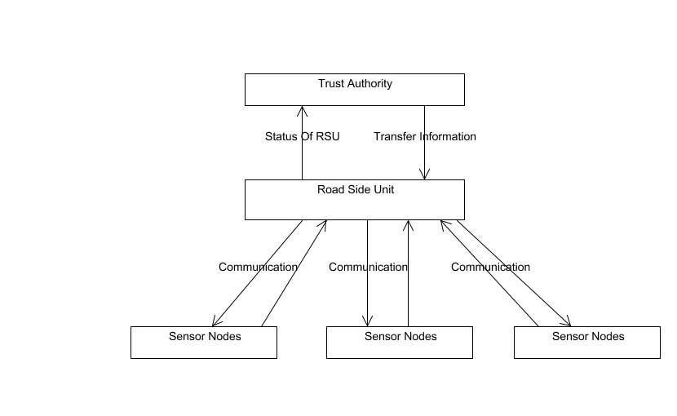

Dataflow Diagram
RSU
RSU
TA(Auth)
OBU
OBU
RSU
TA
RSU
OBU
OBU
RSU
Level 0

Level 1

Level 2

Class Diagram
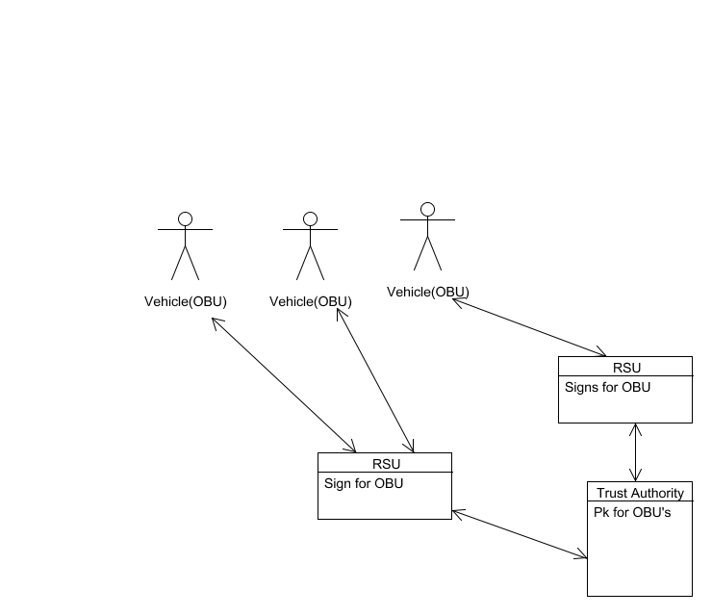

CHAPTER 5

SYSTEM DESIGN
5.1 MODULES
- Design of Infrastructure.
- Location-Hidden Authorization generation.
- Detecting Sybil Attack

5.2 MODULE EXPLANATION:

Design of Infrastructure:
We take an incremental deployment strategy in Footprint, considering the tradeoff between minimizing the number of RSUs and maximizing the coverage of traffic. As more RSUs are available to install, a smaller distance can be used to deploy RSUs .It consist of three initialization process namely 1.Setting up TA, 2. Setting up RSUs, 3. Setting up vehicles:
Location-Hidden Authorization generation
In order to be location hidden, authorized messages issued for vehicles from an RSU should possess two properties, i.e., signer ambiguous and temporarily linkable.
The signer ambiguous property means the RSU should not use a dedicated identity to sign messages. The temporarily linkable property requires two authorized messages are recognizable if and only if they are generated by the same RSU within the same given period of time.

Detecting Sybil Attack
At the conversation, upon request from the conversation holder, all participating vehicles provide their trajectory embedded authorized messages issued within specified event for identification. With submitted messages, the conversation holder verifies each trajectory and refuses those vehicles that fail the message verification. After that, the conversation holder conducts online Sybil attack detection before further proceeding with the conversation.

CHAPTER 6
CODING AND TESTING
6.1 CODING
Once the design aspect of the system is finalizes the system enters into the coding and testing phase. The coding phase brings the actual system into action by converting the design of the system into the code in a given programming language. Therefore, a good coding style has to be taken whenever changes are required it easily screwed into the system.
6.2 CODING STANDARDS
Coding standards are guidelines to programming that focuses on the physical structure and appearance of the program. They make the code easier to read, understand and maintain. This phase of the system actually implements the blueprint developed during the design phase. The coding specification should be in such a way that any programmer must be able to understand the code and can bring about changes whenever felt necessary. Some of the standard needed to achieve the above-mentioned objectives are as follows:

Program should be simple, clear and easy to understand.
Naming conventions
Value conventions
Script and comment procedure
Message box format
Exception and error handling

6.2.1 NAMING CONVENTIONS
Naming conventions of classes, data member, member functions, procedures etc., should be self-descriptive. One should even get the meaning and scope of the variable by its name. The conventions are adopted for easy understanding of the intended message by the user. So it is customary to follow the conventions. These conventions are as follows:
Class names
Class names are problem domain equivalence and begin with capital letter and have mixed cases.
Member Function and Data Member name
Member function and data member name begins with a lowercase letter with each subsequent letters of the new words in uppercase and the rest of letters in lowercase.
6.2.2 VALUE CONVENTIONS
Value conventions ensure values for variable at any point of time. This involves the following:
- Proper default values for the variables.
- Proper validation of values in the field.
- Proper documentation of flag values.

6.2.3 SCRIPT WRITING AND COMMENTING STANDARD
Script writing is an art in which indentation is utmost important. Conditional and looping statements are to be properly aligned to facilitate easy understanding. Comments are included to minimize the number of surprises that could occur when going through the code.
6.2.4 MESSAGE BOX FORMAT
When something has to be prompted to the user, he must be able to understand it properly. To achieve this, a specific format has been adopted in displaying messages to the user. They are as follows:
- X – User has performed illegal operation.
- ! – Information to the user.
6.3 TEST PROCEDURE
SYSTEM TESTING
Testing is performed to identify errors. It is used for quality assurance. Testing is an integral part of the entire development and maintenance process. The goal of the testing during phase is to verify that the specification has been accurately and completely incorporated into the design, as well as to ensure the correctness of the design itself. For example the design must not have any logic faults in the design is detected before coding commences, otherwise the cost of fixing the faults will be considerably higher as reflected. Detection of design faults can be achieved by means of inspection as well as walkthrough.
Testing is one of the important steps in the software development phase. Testing checks for the errors, as a whole of the project testing involves the following test cases:
- Static analysis is used to investigate the structural properties of the Source code.
- Dynamic testing is used to investigate the behavior of the source code by executing the program on the test data.

6.4 TEST DATA AND OUTPUT
6.4.1 UNIT TESTING
Unit testing is conducted to verify the functional performance of each modular component of the software. Unit testing focuses on the smallest unit of the software design (i.e.), the module. The white-box testing techniques were heavily employed for unit testing.
6.4.2 FUNCTIONAL TESTS
Functional test cases involved exercising the code with nominal input values for which the expected results are known, as well as boundary values and special values, such as logically related inputs, files of identical elements, and empty files.

Three types of tests in Functional test:
- Performance Test
- Stress Test
- Structure Test
6.4.3 PERFORMANCE TEST
It determines the amount of execution time spent in various parts of the unit, program throughput, and response time and device utilization by the program unit.
6.4.4 STRESS TEST
Stress Test is those test designed to intentionally break the unit. A Great deal can be learned about the strength and limitations of a program by examining the manner in which a programmer in which a program unit breaks.
6.4.5 STRUCTURED TEST
Structure Tests are concerned with exercising the internal logic of a program and traversing particular execution paths. The way in which White-Box test strategy was employed to ensure that the test cases could Guarantee that all independent paths within a module have been have been exercised at least once.
- Exercise all logical decisions on their true or false sides.
- Execute all loops at their boundaries and within their operational bounds.
- Exercise internal data structures to assure their validity.
- Checking attributes for their correctness.
- Handling end of file condition, I/O errors, buffer problems and textual errors in output information
6.4.6 INTEGRATION TESTING
Integration testing is a systematic technique for construction the program structure while at the same time conducting tests to uncover errors associated with interfacing. i.e., integration testing is the complete testing of the set of modules which makes up the product. The objective is to take untested modules and build a program structure tester should identify critical modules. Critical modules should be tested as early as possible. One approach is to wait until all the units have passed testing, and then combine them and then tested. This approach is evolved from unstructured testing of small programs. Another strategy is to construct the product in increments of tested units. A small set of modules are integrated together and tested, to which another module is added and tested in combination. And so on. The advantages of this approach are that, interface dispenses can be easily found and corrected.
The major error that was faced during the project is linking error. When all the modules are combined the link is not set properly with all support files. Then we checked out for interconnection and the links. Errors are localized to the new module and its intercommunications. The product development can be staged, and modules integrated in as they complete unit testing. Testing is completed when the last module is integrated and tested.
6.5 TESTING TECHNIQUES / TESTING STRATERGIES
6.5.1 TESTING
Testing is a process of executing a program with the intent of finding an error. A good test case is one that has a high probability of finding an as-yet –undiscovered error. A successful test is one that uncovers an as-yet- undiscovered error. System testing is the stage of implementation, which is aimed at ensuring that the system works accurately and efficiently as expected before live operation commences. It verifies that the whole set of programs hang together. System testing requires a test consists of several key activities and steps for run program, string, system and is important in adopting a successful new system. This is the last chance to detect and correct errors before the system is installed for user acceptance testing.
The software testing process commences once the program is created and the documentation and related data structures are designed. Software testing is essential for correcting errors. Otherwise the program or the project is not said to be complete. Software testing is the critical element of software quality assurance and represents the ultimate the review of specification design and coding. Testing is the process of executing the program with the intent of finding the error. A good test case design is one that as a probability of finding an yet undiscovered error. A successful test is one that uncovers an yet undiscovered error. Any engineering product can be tested in one of the two ways:
6.5.1.1 WHITE BOX TESTING
This testing is also called as Glass box testing. In this testing, by knowing the specific functions that a product has been design to perform test can be conducted that demonstrate each function is fully operational at the same time searching for errors in each function. It is a test case design method that uses the control structure of the procedural design to derive test cases. Basis path testing is a white box testing.
Basis path testing:
- Flow graph notation
- Cyclometric complexity
- Deriving test cases
- Graph matrices Control

6.5.1.2 BLACK BOX TESTING
In this testing by knowing the internal operation of a product, test can be conducted to ensure that “all gears mesh”, that is the internal operation performs according to specification and all internal components have been adequately exercised. It fundamentally focuses on the functional requirements of the software.

The steps involved in black box test case design are:
- Graph based testing methods
- Equivalence partitioning
- Boundary value analysis
- Comparison testing

6.5.2 SOFTWARE TESTING STRATEGIES:
A software testing strategy provides a road map for the software developer. Testing is a set activity that can be planned in advance and conducted systematically. For this reason a template for software testing a set of steps into which we can place specific test case design methods should be strategy should have the following characteristics:
- Testing begins at the module level and works “outward” toward the integration of the entire computer based system.
- Different testing techniques are appropriate at different points in time.
- The developer of the software and an independent test group conducts testing.
- Testing and Debugging are different activities but debugging must be accommodated in any testing strategy.

6.5.2.1 INTEGRATION TESTING:
Integration testing is a systematic technique for constructing the program structure while at the same time conducting tests to uncover errors associated with. Individual modules, which are highly prone to interface errors, should not be assumed to work instantly when we put them together. The problem of course, is “putting them together”- interfacing. There may be the chances of data lost across on another’s sub functions, when combined may not produce the desired major function; individually acceptable impression may be magnified to unacceptable levels; global data structures can present problems.

6.5.2.2 PROGRAM TESTING:
The logical and syntax errors have been pointed out by program testing. A syntax error is an error in a program statement that in violates one or more rules of the language in which it is written. An improperly defined field dimension or omitted keywords are common syntax error. These errors are shown through error messages generated by the computer. A logic error on the other hand deals with the incorrect data fields, out-off-range items and invalid combinations. Since the compiler s will not deduct logical error, the programmer must examine the output. Condition testing exercises the logical conditions contained in a module. The possible types of elements in a condition include a Boolean operator, Boolean variable, a pair of Boolean parentheses A relational operator or on arithmetic expression. Condition testing method focuses on testing each condition in the program the purpose of condition test is to deduct not only errors in the condition of a program but also other a errors in the program.
6.5.2.3 SECURITY TESTING:
Security testing attempts to verify the protection mechanisms built in to a system well, in fact, protect it from improper penetration. The system security must be tested for invulnerability from frontal attack must also be tested for invulnerability from rear attack. During security, the tester places the role of individual who desires to penetrate system.

6.5.2.4 VALIDATION TESTING
At the culmination of integration testing, software is completely assembled as a package. Interfacing errors have been uncovered and corrected and a final series of software test-validation testing begins. Validation testing can be defined in many ways, but a simple definition is that validation succeeds when the software functions in manner that is reasonably expected by the customer. Software validation is achieved through a series of black box tests that demonstrate conformity with requirement. After validation test has been conducted, one of two conditions exists.
* The function or performance characteristics confirm to specifications and are accepted.
* A validation from specification is uncovered and a deficiency created.
Deviation or errors discovered at this step in this project is corrected prior to completion of the project with the help of the user by negotiating to establish a method for resolving deficiencies. Thus the proposed system under consideration has been tested by using validation testing and found to be working satisfactorily. Though there were deficiencies in the system they were not catastrophic.
6.5.2.5 USER ACCEPTANCE TESTING
User acceptance of the system is key factor for the success of any system. The system under consideration is tested for user acceptance by constantly keeping in touch with prospective system and user at the time of developing and making changes whenever required. This is done in regarding to the following points.
- Input screen design.
- Output screen design.

Source Code

Screenshots:

REFERENCES
[1] Y. Sun, R. Lu, X. Lin, X. Shen, and J. Su, “An Efficient Pseudonymous Authentication Scheme with Strong Privacy Preservation for Vehicular Communications,” IEEE Trans. Vehicular Technology, vol. 59, no. 7, pp. 3589-3603, Sept. 2010.
[2] R. Lu, X. Lin, H. Zhu, and X. Shen, “An Intelligent Secure and Privacy-Preserving Parking Scheme through Vehicular Communications,” IEEE Trans. Vehicular Technology, vol. 59, no. 6,
pp. 2772-2785, July 2010.

[3] J.R. Douceur, “The Sybil Attack,” Proc. First Int’l Workshop Peer-to-Peer Systems (IPTPS ’02), pp. 251-260, Mar. 2002. CHANG ET AL.: FOOTPRINT: DETECTING SYBIL ATTACKS IN URBAN VEHICULAR NETWORKS 1113 Fig. 5. Trajectory length limit versus false positive error and false negative error. Fig. 6. RSU deployment versus false positive error and false negative error.

[4] J. Eriksson, H. Balakrishnan, and S. Madden, “Cabernet: Vehicular Content Delivery Using WiFi,” Proc. MOBICOM ’08, pp. 199-210, Sept. 2008.

[5] M. Castro, P. Druschel, A. Ganesh, A. Rowstron, and D.S. Wallach, “Secure Routing for Structured Peer-to-Peer Overlay Networks,” Proc. Symp. Operating Systems Design and Implementation (OSDI ’02), pp. 299-314, Dec. 2002.

[6] B. Dutertre, S. Cheung, and J. Levy, “Lightweight Key Management in Wireless Sensor Networks by Leveraging Initial Trust,” Technical Report SRI-SDL-04-02, SRI Int’l, Apr. 2002.

[7] J. Newsome, E. Shi, D. Song, and A. Perrig, “The Sybil Attack in Sensor Networks: Analysis & Defenses,” Proc. Int’l Symp. Information Processing in Sensor Networks (IPSN ’04), pp. 259-268, Apr. 2004.

[8] S. Capkun, L. Buttya_n, and J. Hubaux, “Self-Organized Public Key Management for Mobile Ad Hoc Networks,” IEEE Trans. Mobile Computing, vol. 2, no. 1, pp. 52-64, Jan.-Mar. 2003.

[9] C. Piro, C. Shields, and B.N. Levine, “Detecting the Sybil Attack in Mobile Ad Hoc Networks,” Proc. Securecomm and Workshop, pp. 1- 11, Aug. 2006.

[10] N. Borisov, “Computational Puzzles as Sybil Defenses,” Proc. Sixth IEEE Int’l Conf. Peer-to-Peer Computing (P2P ’06), pp. 171-176, Oct. 2006.

[11] P. Maniatis, D.S.H. Rosenthal, M. Roussopoulos, M. Baker, T. Giuli, and Y. Muliadi, “Preserving Peer Replicas by Rate-Limited Sampled Voting,” Proc. 19th ACM Symp. Operating Systems Principles (SOSP ’03), pp. 44-59, Oct. 2003.

[12] H. Yu, M. Kaminsky, P.B. Gibbons, and A. Flaxman, “Sybilguard: Defending against Sybil Attacks via Social Networks,” Proc. SIGCOMM, pp. 267-278, Sept. 2006.

[13] M.S. Bouassida, G. Guette, M. Shawky, and B. Ducourthial, “Sybil Nodes Detection Based on Received Signal Strength Variations within Vanet,” Int’l J. Network Security, vol. 9, no. 1, pp. 22-32, 2009.

[14] B. Xiao, B. Yu, and C. Gao, “Detection and Localization of Sybil Nodes in Vanets,” Proc. Workshop Dependability Issues in Wireless Ad Hoc Networks and Sensor Networks (DIWANS ’06), pp. 1-8, Sept. 2006.

[15] T. Zhou, R.R. Choudhury, P. Ning, and K. Chakrabarty, “Privacy- Preserving Detection of Sybil Attacks in Vehicular Ad Hoc Networks,” Proc. Fourth Ann. Int’l Conf. Mobile and Ubiquitous Systems: Networking and Services (MobiQuitous ’07), pp. 1-8, Aug. 2007.

